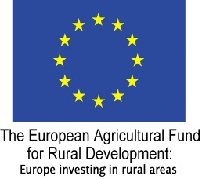

**HIGHLAND LEADER PROGRAMME 2014 – 2020**

**ENGAGING COMMUNITIES**

**FAIRER HIGHLAND – ACCESSIBLE CHECKLIST**

This is a checklist that organisations and businesses can use to assess and improve their services in relation to producing Engaging Communities.

### Developing or changing services is best done through engaging and involving those affected by your activities. Here are some actions you can take to ensure that the community engagement activities that you undertake are inclusive. Please note these are intended as a guideline only, and may or may not be relevant depending on the nature of your activity. For more information, please see reference section below.

### Involve people and groups in engagement at the earliest opportunity.

### Put in place measures to involve groups with protected characteristics and people who might feel excluded from participating due to disadvantage relating to social or economic factors.

### Ensure that a wide range of opinions, including minority and opposing views, are valued in the engagement process.

### Consider providing a range of inclusive ways to participate in any form of community engagement, e.g. focus groups or electronic surveys, and use different media to appeal to different ages and genders, for example video and tele-conferencing, internet, social media.

* Consider access needs of those taking part in any type of engagement
* Use of Plain English and language appropriate to the intended audience.
* Use of Easy Read principles where appropriate for people with learning disabilities.
* Make use of existing networks and intermediary groups to engage with specific audiences.
* Target publicity to specific audiences using appropriate language and media.
* Provide feedback to those participating so they can see how their views have been listened to.
* If appropriate, use forms throughout process to capture information on who is taking part (age, disability, ethnicity, etc.) and invite feedback on accessibility to help improve future engagement.

**References**

National Standards for Community Engagement

http://www.voicescotland.org.uk/

**Plain English guidance**

[www.plainenglish.co.uk/](http://www.plainenglish.co.uk/)

**Easy Read guidelines**

[www.eqwualityhumanrights.com/](http://www.eqwualityhumanrights.com/)

**Holding Public Events – Fairer Highland – Accessible Checklist**

**Producing Publications and Print – Fairer Highland Accessible Checklist**