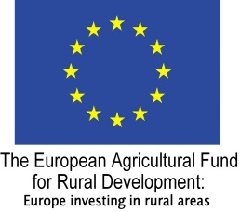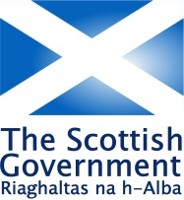

**HIGHLAND LEADER PROGRAMME 2014 – 2020**

**HOLDING PUBLIC EVENTS**

**FAIRER HIGHLAND – ACCESSIBLE CHECKLIST**

This is a checklist that organisations and businesses can use to assess and improve their services – in relation to holding events - so that they are accessible to the full diversity of people.It considers the potential impacts on disability, gender, race, age, sexual orientation and religion/faith. It can also be useful as a checklist for staff when completing Equality Impact Assessments for their own work.

Here are some actions you can take to ensure that public events you hold are accessible and inclusive. **Please note these are intended as a guideline only, and may or may not be relevant depending on the nature of your activity.** For more information, please see reference section below.

Disability/Age

* Ensure venues, including toilets, are accessible (as practically as possible), with a pre-visit if unfamiliar.
* Ensure that staff, external facilitators and speakers attending the event are familiar with holding accessible meetings guidance (see References) and are aware of the audience and any accessibility needs.
* In publicity, provide information on transport, for example public transport times, care share to encourage young people, non-drivers to take part.
* Use of Plain English and language appropriate to the intended audience, for example young people.
* Use of Easy Rad principles where appropriate for people with learning disabilities.
* Provide a range of events and use different media to appeal to different ages and genders, for example video and tele-conferencing, internet, social media.

Gender

* Hold some events which are family friendly, for example providing childcare, crèche, ranger walk, DVD, toys etc.
* Offer to reimburse participants for the cost of child/other care and let people know about this in promotion materials for events.
* Provide private space for nursing mothers.
* Provide accessible toilets facilities for all genders.
* Consider taking meetings to a specific audience/interest group, for example playgroup.

Race

* Use of Plain English in printed/promotional materials.
* Be aware of the sensitivities of some cultures, for example regarding gender.

Religion

* Ensure events are held at appropriate times, days and venues according to the intended audience, for example avoid religious festivals.

General

* In publicity materials, ask your audience if they have and **‘special access or dietary requirements’** so that these can be catered for.
* In publicity materials, provide contact details for event organiser so that people can contact your organisation in advance, to discuss access or other requirements.
* Offer travel expenses and subsistence to enable volunteers to attend meetings
* Provide and promote video and tele-conferencing facilities where available, and provide training in the use of these.
* Use feedback forms at public events to capture information on who is attending (age, disability, ethnicity etc.) and invite feedback on accessibility to improve future events.

**References**

**Plain English guidance**

[www.plainenglish.co.uk/](http://www.plainenglish.co.uk/)

**Easy Read guidelines**

[www.equalityhumanrights.com/](http://www.equalityhumanrights.com/)

**Centre for Accessible Environments**

[www.cae.org.uk/](http://www.cae.org.uk/)

**Scottish Disability Equality Forum**

www.sdef.org.uk/

**Equality and Human Rights Commission**

[www.equalityhumanrights.com](http://www.equalityhumanrights.com)

**Producing Publications and Print – Fairer Highland Accessible Checklist**

**Ebgaging Communities - Fairer Highland Accessible Checklist**